Duration Adjunct

✅ What Is a Duration Adjunct?
# Source: AI Source: Provided by: [Data Path: Persons Table -> ID Column: 1, Name_En Column: Motasem Essam] -> From: [Chatgpt (GPT-4-turbo)] on [8/6/2025]
A duration adjunct provides information about how long an action or event lasts. It adds non-essential but meaningful detail about the length of time during which something happens.
It answers the question:
- How long?

🔸 Common Forms of Duration Adjuncts:
# Source: AI Source: Provided by: [Data Path: Persons Table -> ID Column: 1, Name_En Column: Motasem Essam] -> From: [Chatgpt (GPT-4-turbo)] on [8/6/2025]
- Prepositional Phrases: for two hours, during the meeting, throughout the night
- Time Expressions: all day, all night, the whole week, briefly
- Adverbs: long, forever, temporarily

🔸 Examples of Duration Adjuncts in Sentences:
# Source: AI Source: Provided by: [Data Path: Persons Table -> ID Column: 1, Name_En Column: Motasem Essam] -> From: [Chatgpt (GPT-4-turbo)] on [8/6/2025]
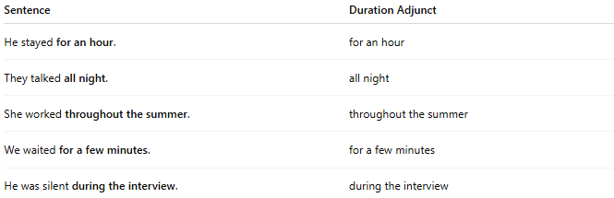
Sentence | Duration Adjunct
He stayed for an hour. | for an hour
They talked all night. | all night
She worked throughout the summer. | throughout the summer
We waited for a few minutes. | for a few minutes
He was silent during the interview. | during the interview

🔸 Position in the Sentence:
# Source: AI Source: Provided by: [Data Path: Persons Table -> ID Column: 1, Name_En Column: Motasem Essam] -> From: [Chatgpt (GPT-4-turbo)] on [8/6/2025]
- Final (most common): She studied for three hours.
- Initial: During the holidays, we stayed home.
- Medial (less common): She has briefly worked there.

🔸 Reminder:
# Source: AI Source: Provided by: [Data Path: Persons Table -> ID Column: 1, Name_En Column: Motasem Essam] -> From: [Chatgpt (GPT-4-turbo)] on [8/6/2025]
A duration adjunct tells how long something happens, but it is not grammatically required.
🟢 "He waited."
🟡 "He waited for an hour." → Duration adjunct adds time length

